Scorecard Management Requirements Specification

Scope

Overview
A scorecard is a template to produce reviews. The scorecard hierarchy consists of groups, sections and questions. Weight can be assigned on each level to control the contribution to the overall score of the scorecard. Different question types are supported and each question will allow a document, test log for instance, to be uploaded in addition. A scorecard has minimum and maximum passing score, as well as type, status and category attributes. A simple versioning mechanism will be built, where only scorecards not currently in use can be modified.

The component provides the management functionalities to create, update or search scorecards. The scorecard persistence logic is pluggable.

Logic Requirements

Scorecard Management Operations
This component will support the following operations.

Create Scorecard
A new scorecard can be created. The identifiers will be provided with ID Generator. Scorecard should be validated.

The operator needs to be provided for auditing purpose.

Update Scorecard
An existing scorecard can be updated. The identifiers of any new entities will be provided with ID Generator. Scorecard should be validated.

When a scorecard is successfully updated, its minor version number should be incremented. The minor version number is the numeric value after the last dot in the scorecard version. If the minor version number does not exist then “.1” (dot one) should be appended to the version.

The operator needs to be provided for auditing purpose.

Get Scorecard
A scorecard can be retrieved by specified identifier.

Search Scorecards
An array of scorecards can be retrieved by specified search criteria. An option should be able to specify whether to retrieve the complete scorecard hierarchies or only the scorecard instances.

Scorecard Search Criteria
At minimum, the criteria should be capable of specifying any combination of scorecard type, scorecard status, project category, project, name and version.

All Scorecard Types
There should be a way to retrieve all scorecard types in the system.

All Question Types
There should be a way to retrieve all question types in the system.

All Scorecard Statuses
There should be a way to retrieve all scorecard statuses in the system.

Search Builder Usage
Search Builder should be used with the searching functionality. Only the identifiers of the entities should return from the Search Builder. Convenient methods should be provided to create the applicable filters.

Auditing Fields
Scorecard must also include auditing fields of creation/modification operator and timestamp. These fields will not be provided by component users.

Persistence
Persistence needs to be pluggable. For this release an Informix plug-in will be developed. The SQL scripts will be provided.

Persistence Implementation
The persistence implementation needs to be designed in this component, but will be separated into a second development project. Please put all persistence implementation related information into a separate sub-package and clearly mark the responsibilities of the two development projects.

Informix Plug-in
Notice for this plug-in the in use attribute of the scorecard is read only. It will be true if it is referenced in the phase_criteria table, false otherwise.

Required Algorithms
No specific algorithms are required.

Example of the Software Usage
A scorecard/review application can use the component as a model layer. Application user can create and modify scorecards on the web interface.

Future Component Direction
Separate component will be developed to calculate review scores. XML persistence plug-in can be developed to provide better drop in convenience.

Interface Requirements

Graphical User Interface Requirements
None.

External Interfaces
Design must adhere to the interface diagram definition. Designer can choose to add more methods to the classes/interfaces, but must keep the ones defined on the diagram as a minimum. Source files can be found in the distribution.
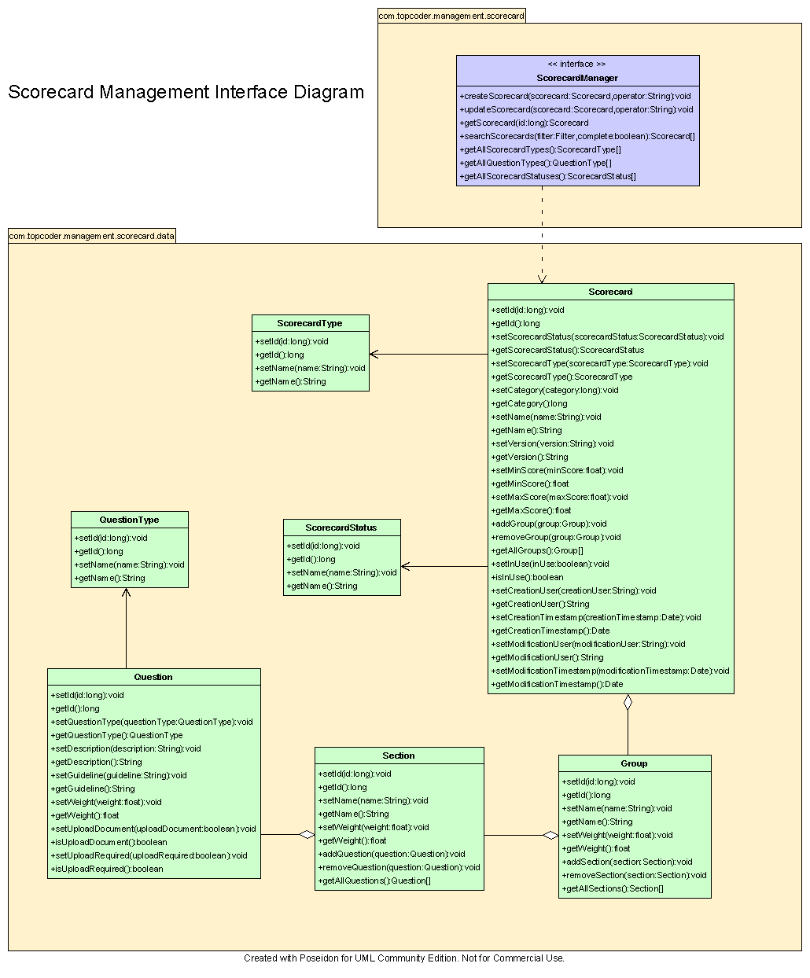

Environment Requirements
- Development language: Java1.4
- Compile target: Java1.4

Package Structure
com.topcoder.management.scorecard

Software Requirements

Administration Requirements

What elements of the application need to be configurable?
- Database connection

Technical Constraints

Are there particular frameworks or standards that are required?
JDBC

TopCoder Software Component Dependencies:
- Scorecard Data Structure
- Configuration Manager
- DB Connection Factory
- ID Generator
- Search Builder

**Please review the TopCoder Software component catalog for existing components that can be used in the design.

Third Party Component, Library, or Product Dependencies:
None.

QA Environment:
- Solaris 7
- RedHat Linux 7.1
- Windows 2000
- Windows 2003
- Informix 10.0

Design Constraints
The component design and development solutions must adhere to the guidelines as outlined in the TopCoder Software Component Guidelines.

Database Connections
Database connections must not be cached within the component. Connections should be created for each operation and closed afterwards.

Component Scalability
The component needs to be scalable. Running multiple instances in the same JVM or in multiple JVM’s concurrently should not cause any problem.

Required Documentation

Design Documentation
- Use-Case Diagram
- Class Diagram
- Sequence Diagram
- Component Specification

Help / User Documentation
- Design documents must clearly define intended component usage in the ‘Documentation’ tab of Poseidon.

